***Hive 牛刀小試 (1-1)***

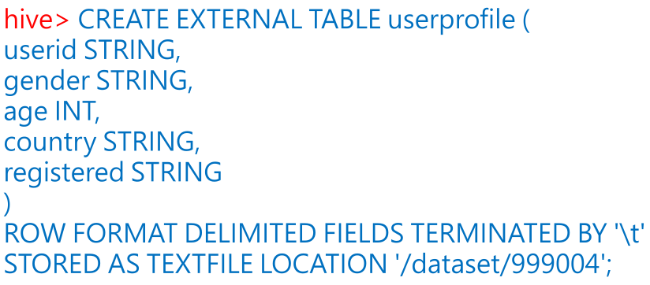

***Hive 牛刀小試 (1-2)***

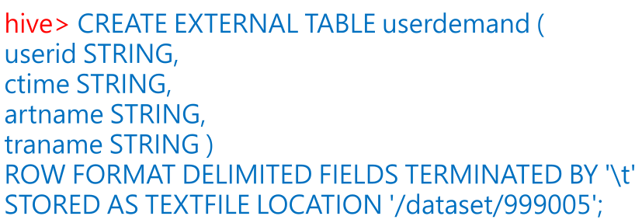

***Hive 牛刀小試 (1-3)***



***Hive 牛刀小試 (2-1)***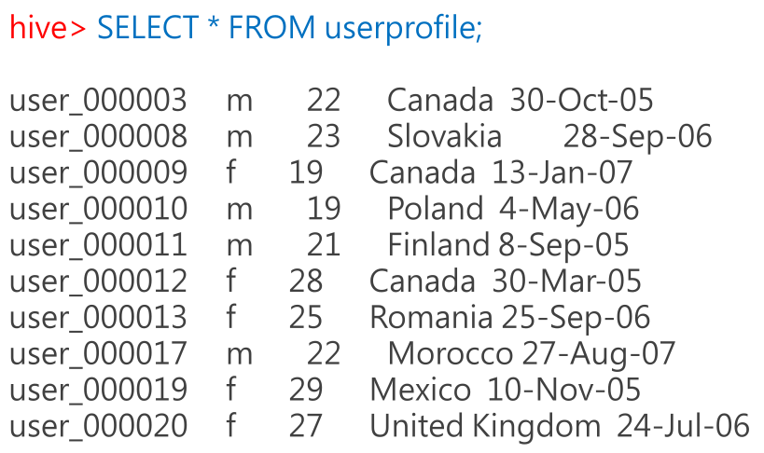

***Hive 牛刀小試 (2-2)***

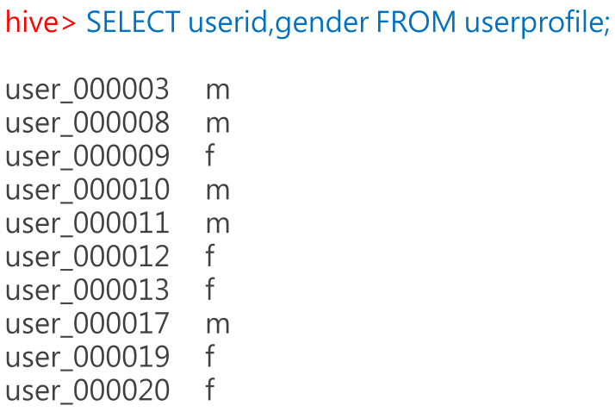

***Hive 牛刀小試 (3-1)***

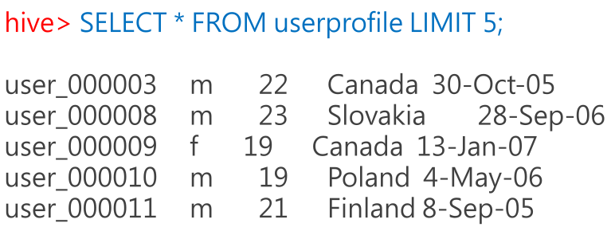

***Hive 牛刀小試 (4-1)***

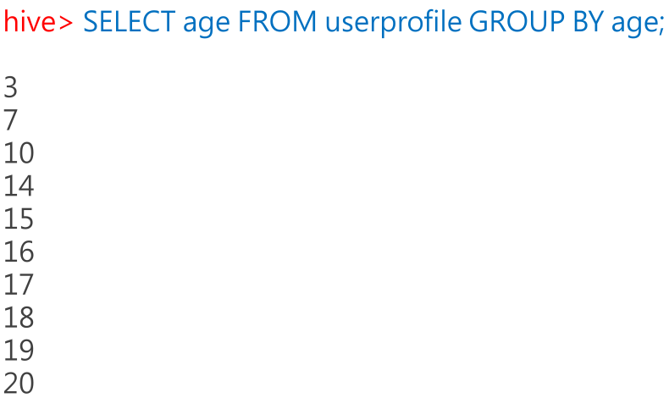

***Hive 牛刀小試 (4-2)***

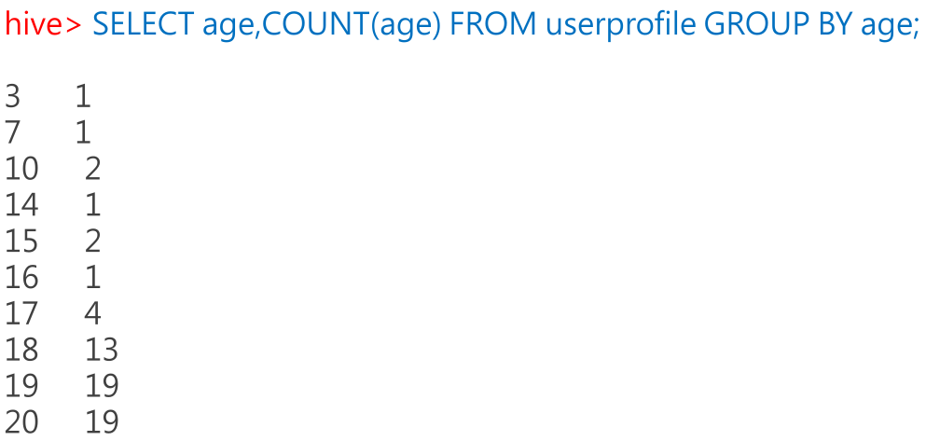

***Hive 牛刀小試 (4-3)***

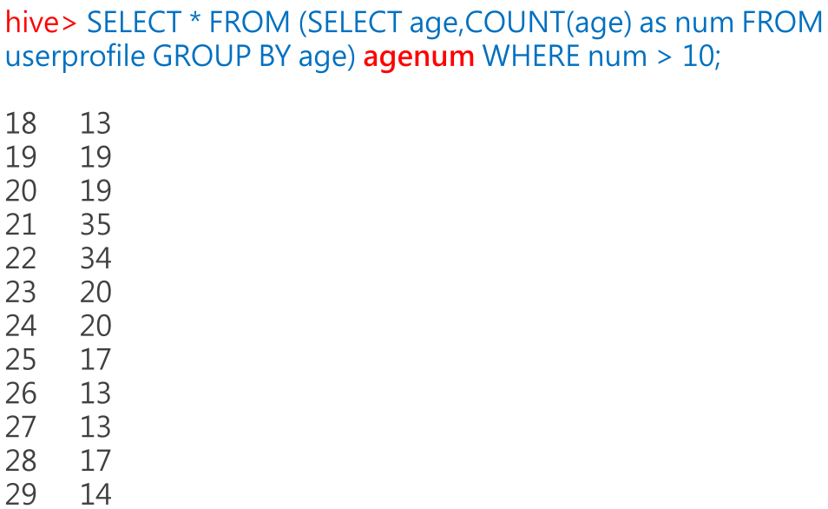

***Hive 牛刀小試 (5-1)***

